Lyft

[hero image]

# Overview

Lyft was a redesign project passed to us to develop. We started by choosing a critical path, our project scope. In a 10-week timespan, what would we choose to develop that would prove our skills as designers and teach us important technical skills? That option was the analytics route of the project. To manage and deliver data content to an average user, in a presentable and understandable way.

# Context & Challenge

As a team we were challenged with developing a critical path from a given prototype. That critical path being the ride history page. We outlined tangible tasks and milestones such as an alpha and beta and sought to develop the Lyft prototype that we were given. In a timeline of 10 weeks we worked tirelessly to develop an online prototype. The purpose of the project was to give us valuable experience working in a team environment and to teach important technical skills. Our goal was to be able to meet deadlines while working within our given role as part of the team using Github and Microsoft Teams for development and communication.

# Process and Insight

The team obtained designs from the previous team’s work and improved on it. Our team based on our input and leftover UX testing notes adjusted the designs for future development.

## User Persona

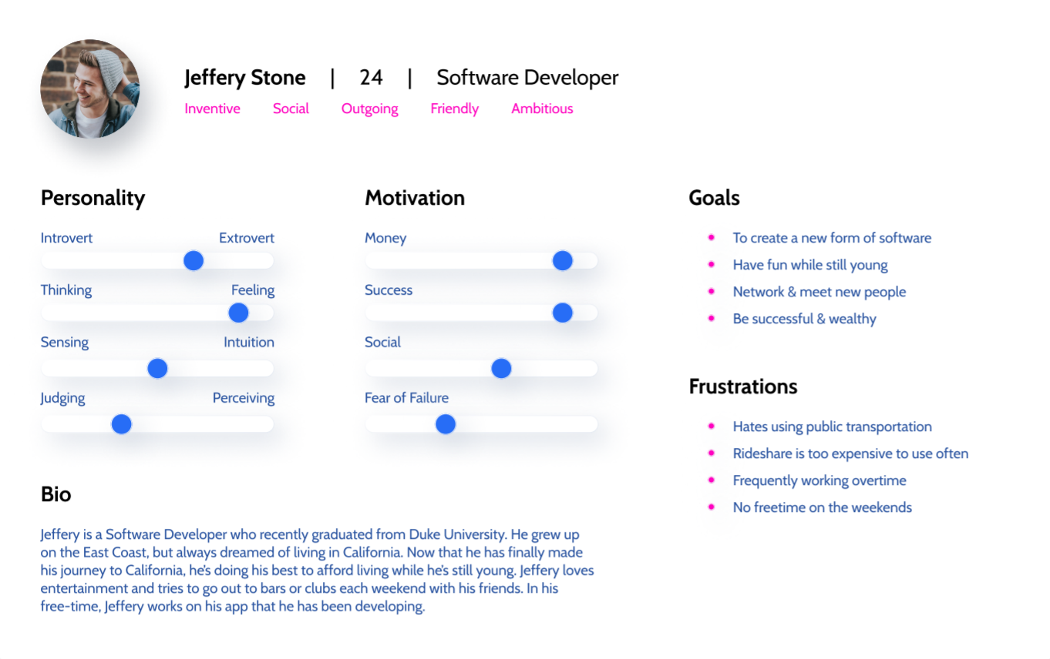

## Style Guide

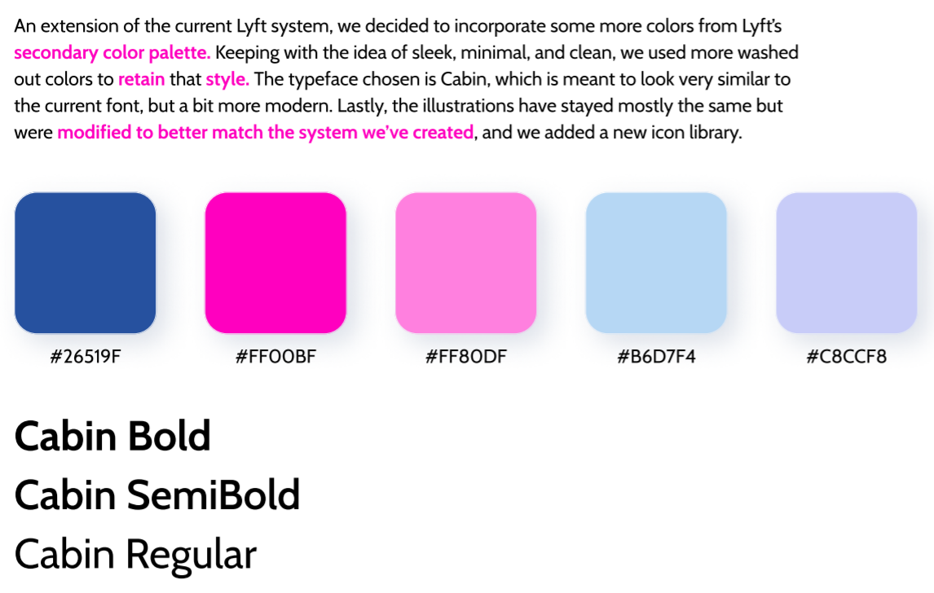

## Wireframe Design

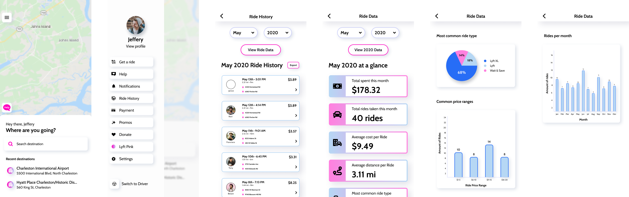

For the design, the team decided to choose the “ride history data” as our critical path. This focused on Ride History allowing the user to view a monthly overview of the user’s ride data as well as a year overview.

Prototypes

Alpha

### [Images to use: menu_microinteraction.gif, alpha_rideHistory.png, alpha_rideData2020.png]

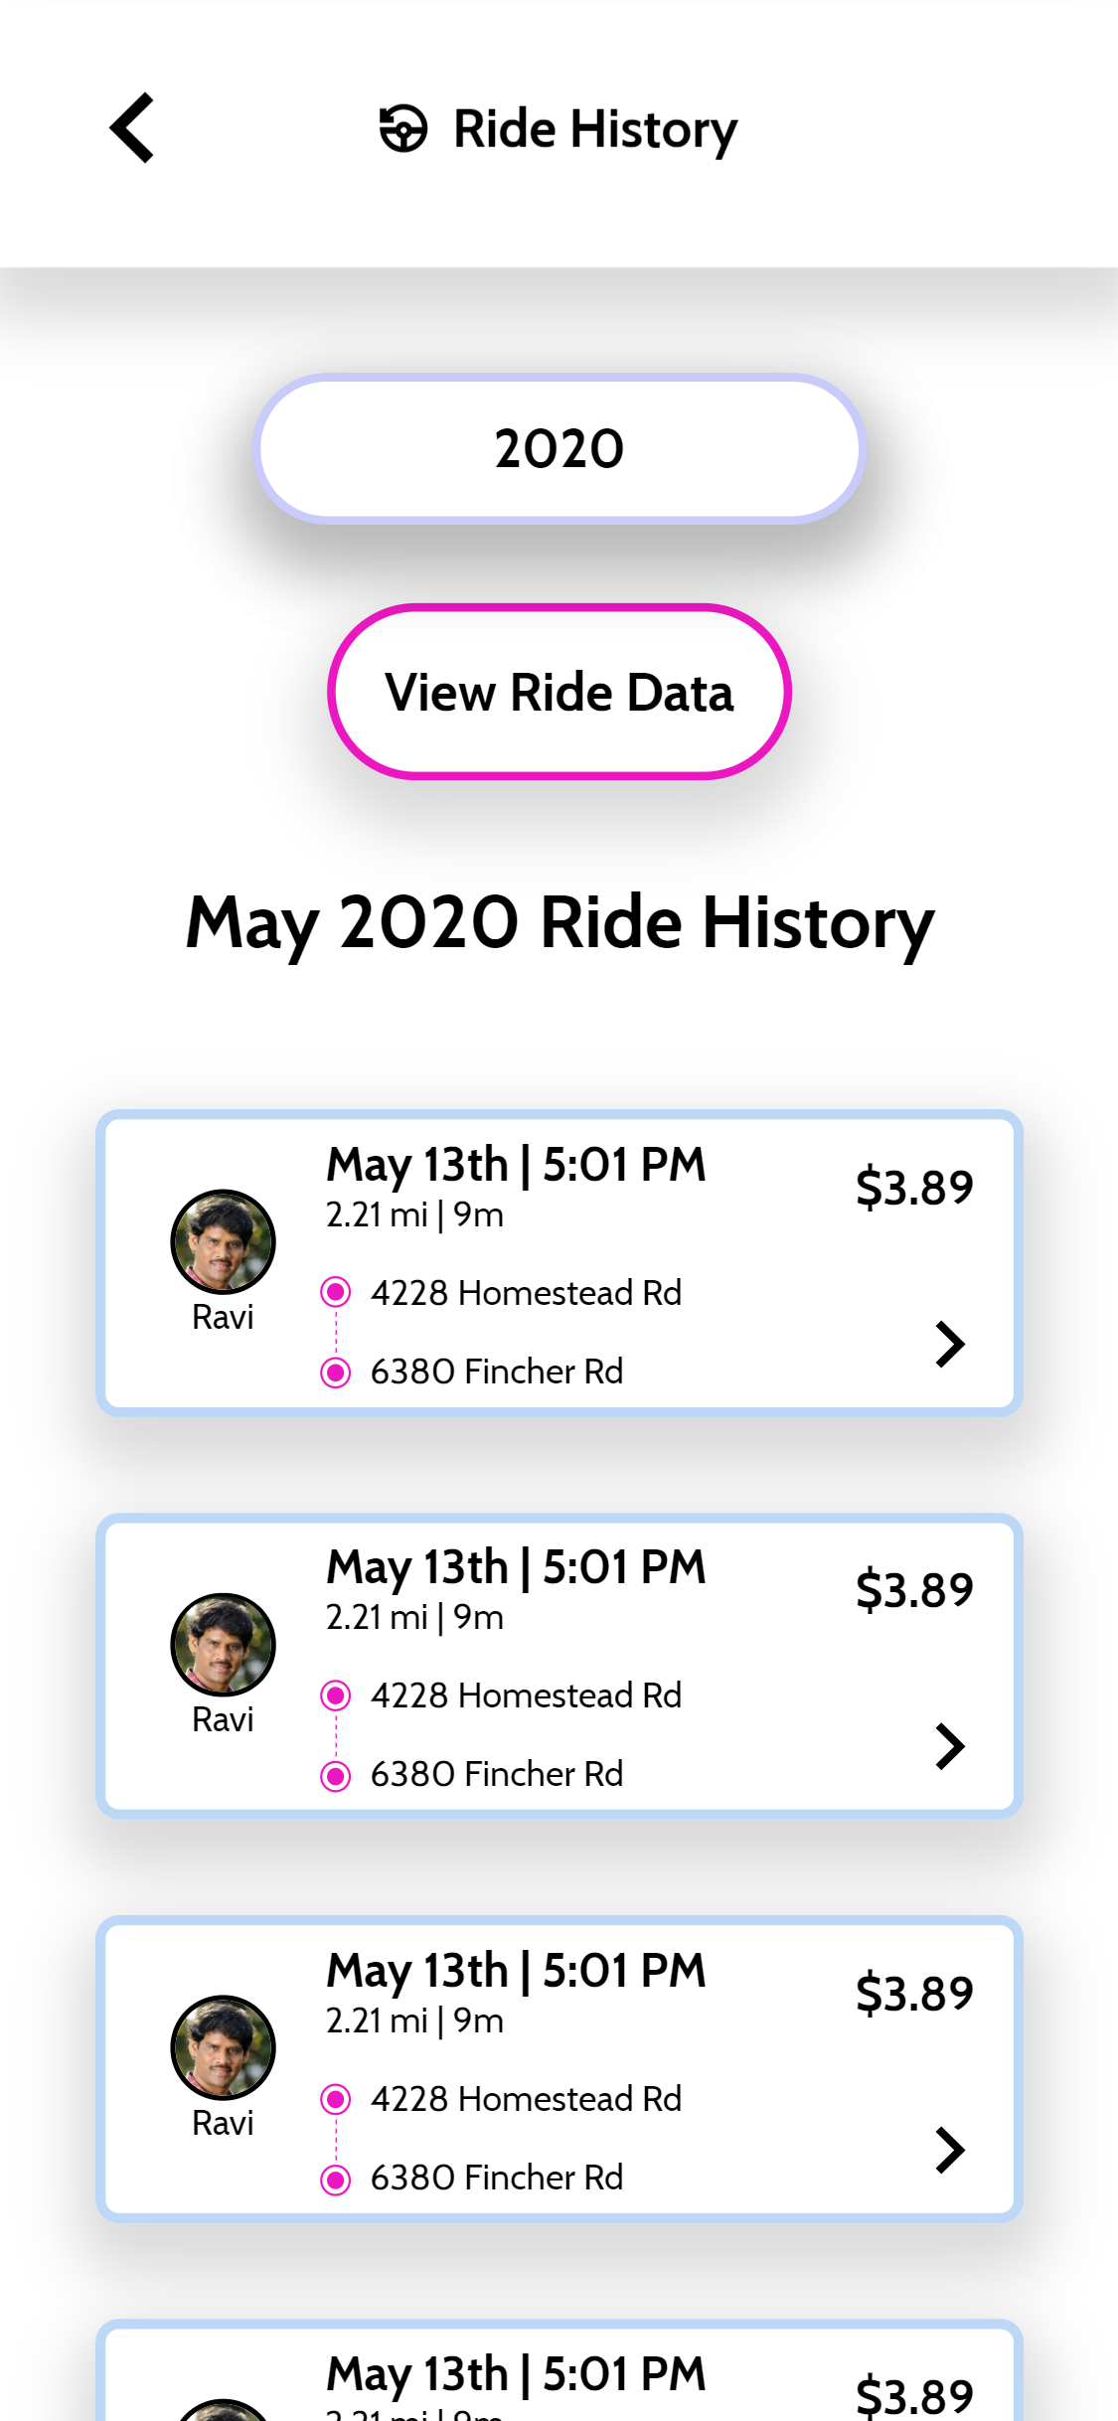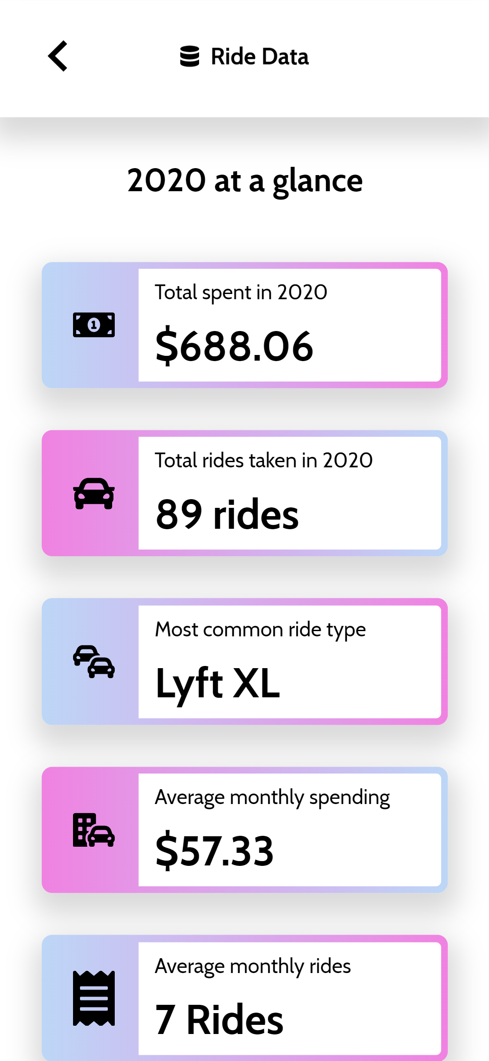

* + - Static page
      * Some micro interaction with the menu opening
      * Team unsure about implementing export feature
      * Focus was to match the static site to the figma file
    - UX changes made for Alpha
      * Font size too small
      * Add drop down arrows to the intended dropdown
      * Rename buttons, ‘View [XXXX] Month's Data’

### Beta

### [Images to use: beta_dropDown.gif, beta_rideData_dec2019.png, beta_rideData_2019.png]

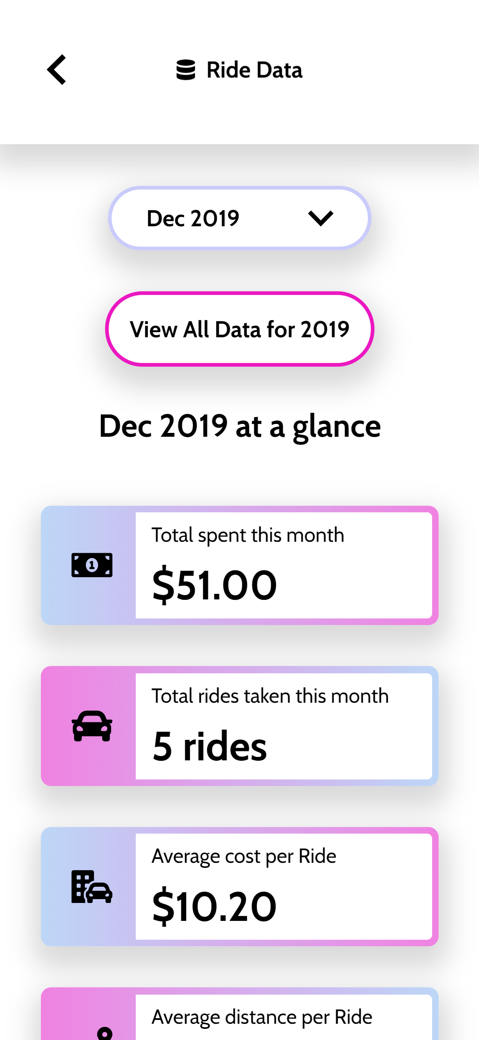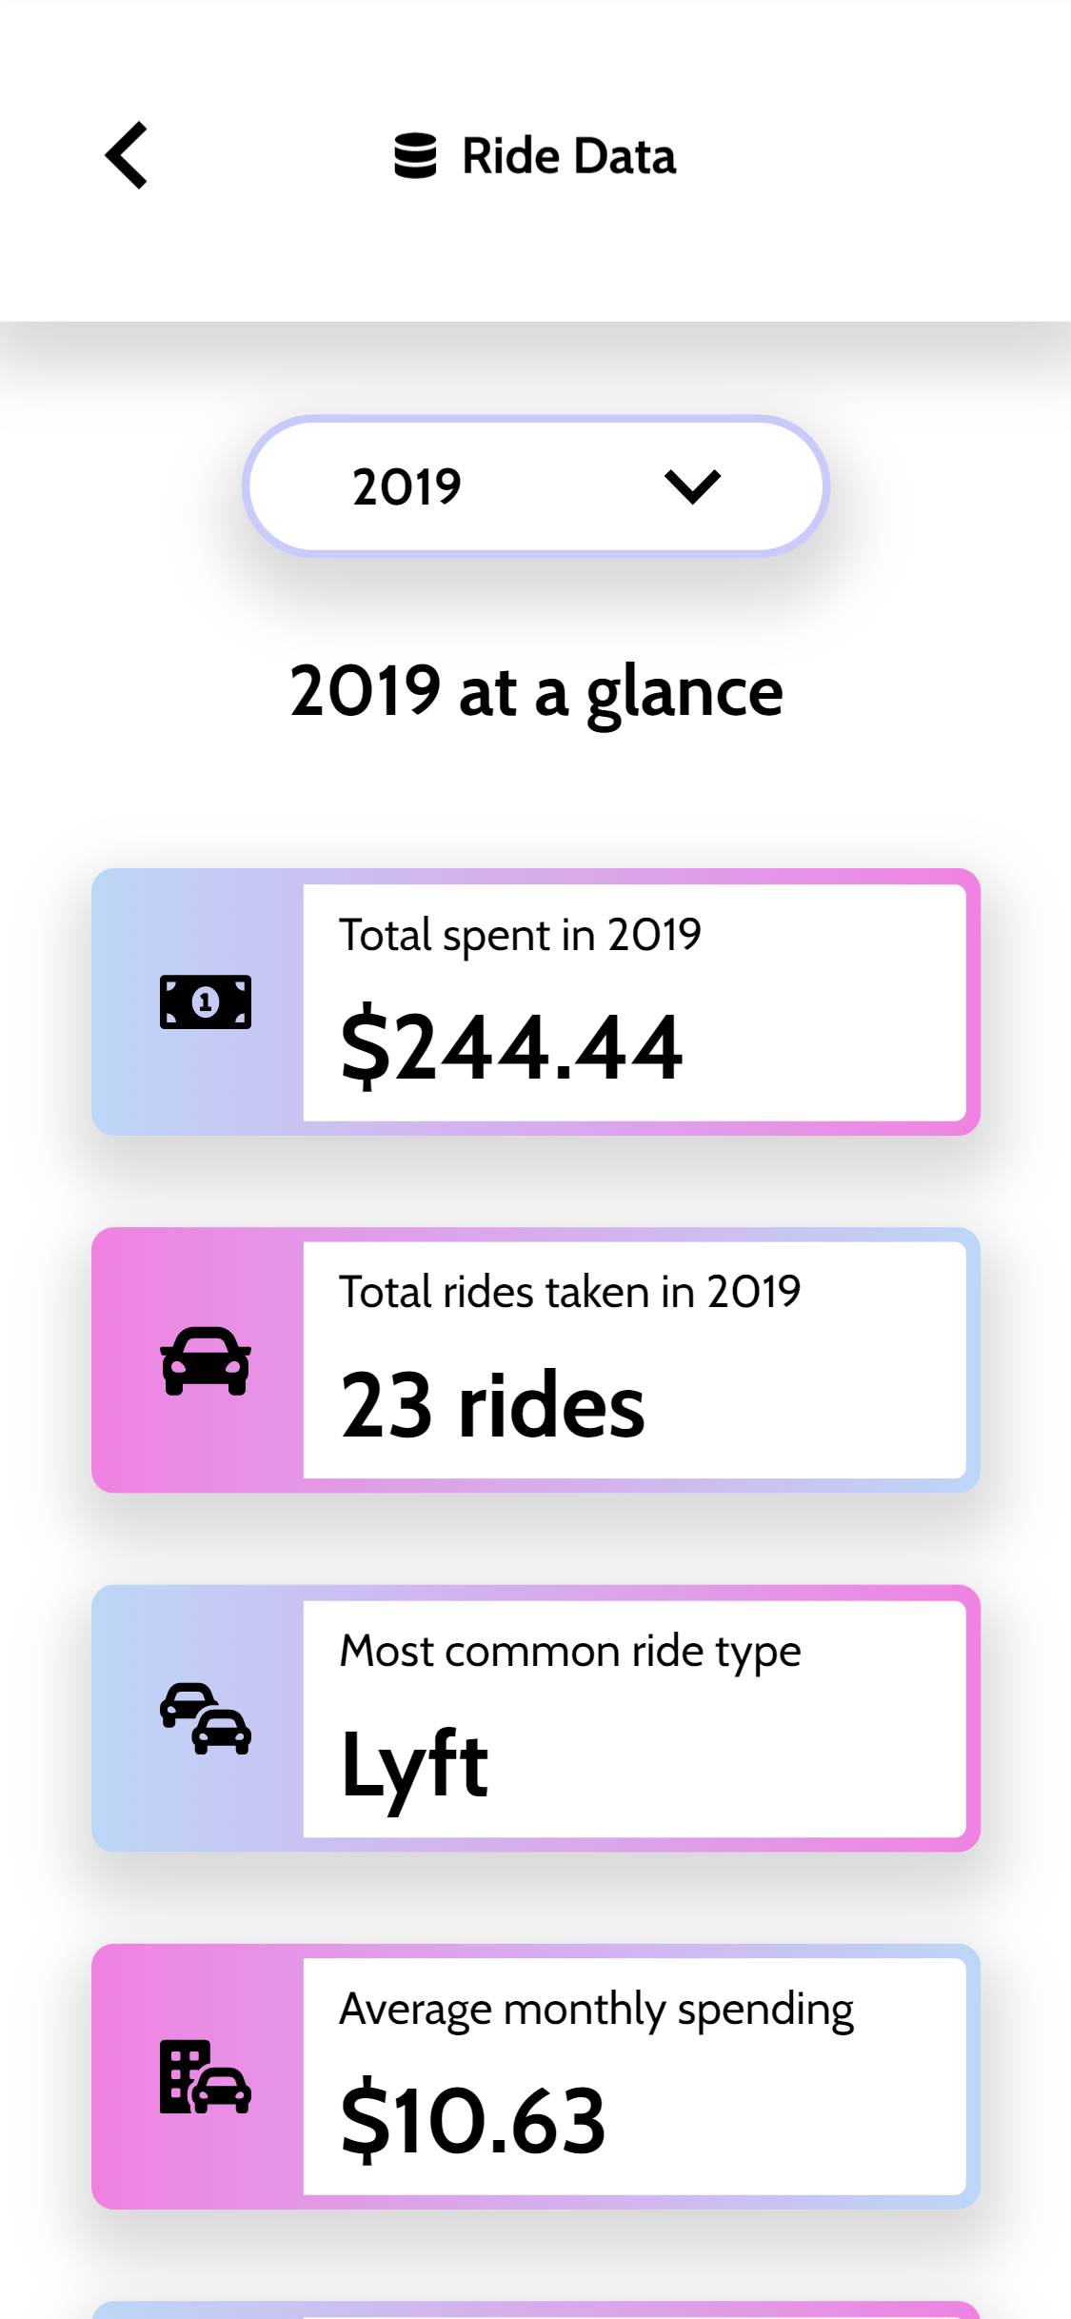

* + - PHP implementation
    - UX changes made for Beta
      * iPhone SE - Landscape warning doesn't work, use Landscape Media Query
        + Get rid of option to get out of landscape warning as it was unnecessary to be able to close it
      * Ride history card title: font size decrease
      * Change ride type in database to reflect additional types
      * Overlay the drop down
        + Change font size to 16pt
        + Compare full month name to 3 letter shortened version (went with shortened)
        + The backend influenced a UI change by combining the year and month buttons into a single button, this made much more sense for our users as the original design did not come with an action button.
      * Have the year/month remembered between pages based on dropdown selection

Code/Dev

PHP was really the core of our project, it played a very heavy hand in content delivery, design decisions, and website structure. Our app is driven by historical records of ride history, built dynamically, no detail was left out here. You could add as much data as you want, and this machine will deliver.

* + Google Maps
    - Interactable map on the home screen to view an interactive map of the Philadelphia Center City area using the Google Maps JavaScript API. Used to simulate a more realistic interface for Lyft.
  + Google Graphs
    - Using the information from the database used the API to generate dynamic graphs that will make changes based on the data for that month and year.

## Final Project

### [Images to use: final_rideHistory.png, final_rideData.png, final_rideData._graphs.png]

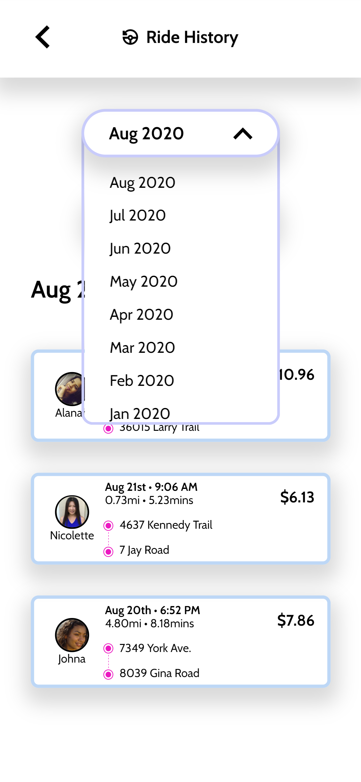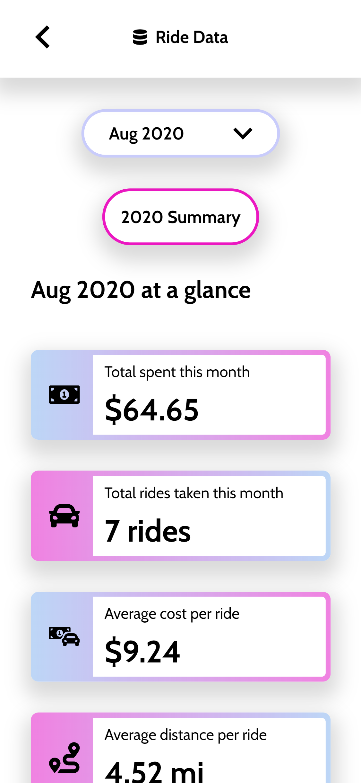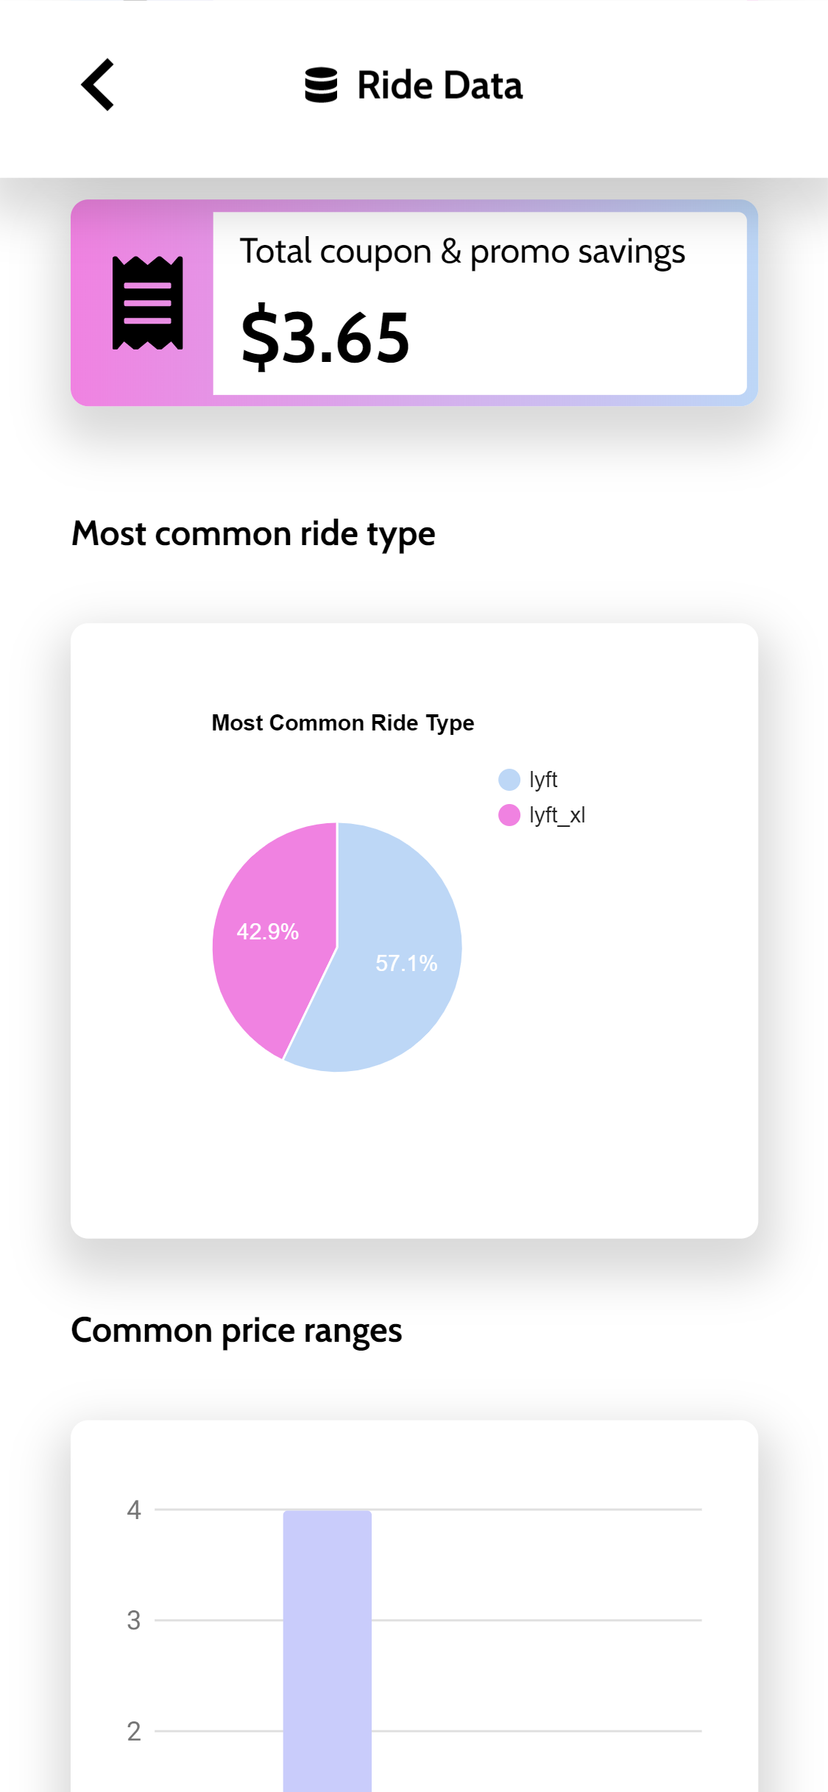

For the final version before the deadline there was come quick CSS cleanup for the site as well as some changes based on user testing.

* + UX changes made for final
    - Drop Export Button
      * UX test said 80% won’t really use the feature
    - Descending drop-down options when selecting month/year
    - Change button names based on NEW test.
      * Ended up with [YYYY] Summary
    - Remove arrow in cards for drivers and some data that were displayed
    - Style Google chart API’s

# Solution

[video screen cap of site; use final_screencap.mp4]

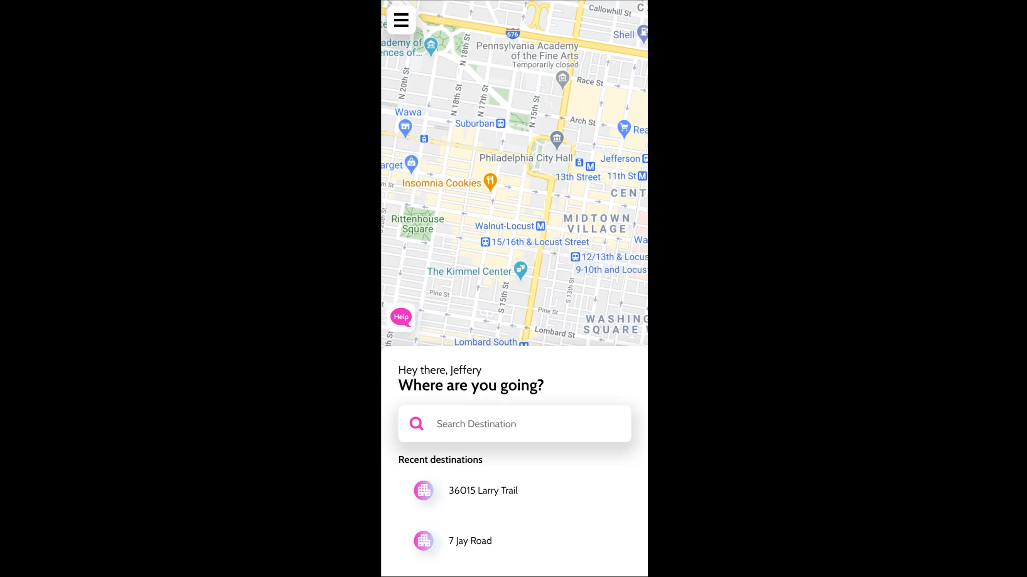

With the final design we implemented what we set out to do and took into consideration any concerns about the design during our user testing. Some unique features that were used in creating the Lyft site were Google Maps and Google Graphs as they allowed the data that the user can see be dynamically driven and view in a modern and clean way.

[button link to site]

# Results

As a team we believe this project of redesigning the Lyft site to be a success. We learned how we can work as a team and the process behind that. From a technical standpoint, we learned how to communicate and use GitHub as a team as opposed to individual use, as well as using PHP to make the site efficient and dynamic.

In hindsight, in terms of development, we should have planned and structured out project thinking farther forward. Some challenges included link changes, file re-structuring, and naming conventions. Considering those far in advance would have been helpful and caused fewer tedious tasks. In terms of UX testing, we could have thought smaller in some cases, asking very basic questions such as ‘do you want this?’ instead of assuming the answer was yes.

Overall, this project was a valuable learning experience for the team. As we learned what each of our roles were within the team, we have set out to develop a critical path for the Lyft redesign to develop the online prototype we have today.

# **~~ Guideline BELOW ~~**

##### Hero Image

Show hero image of final project

##### The Overview

This the executive summary of your case study. It allows your prospects to quickly understand the highlights of your past work without reading the entire thing. This section should include the core takeaways from all other sections including the main problem, an overview of the solution, and key results. This is typically written last, so that you can scan for the main points from each section below and summarize them into a one or two paragraph synopsis.

##### The Context and Challenge

This section is designed to provide your prospective client with a detailed description of the context that led to the creation of the project, and can be distilled into three main elements:

1. Background / Description / Timeline / Budget / Purpose
2. The Problem: Define why this project exists and what problem it seeks to solve.
3. Goals & Objectives: What are the metrics that will define if this project is successful. What are the tangible goals.

Give a quick overview of the project. What were the goals for the project? Keep the focus on problem-solving, not just asset delivery. Define if it was a solo or team-based project. If team based, what your role was on the project.

##### The Process and Insight

This section should elaborate on your design process. How did you go about developing the final solution? What were the steps that will help the reader to visualize the work and, more importantly, to see that it was created by human beings? We want to see how the final came into being, not just what the piece looks like at the end. These could include (but not limited to) research:

* Target Audience / User Personas
* User Journeys
* Design Sketches
* Wireframes
* Style Guide
* Prototypes
* Code/Dev
* UX Testing Notes
* Final Project

**If this was a team-based project, make sure to define your specific contributions to the project. When was there team consensus, and what were you specifically responsible for? Be sure to include images / video for each stage of the process as appropriate.**

##### The Solution

This is where you get to show off your final design with detailed images and videos, and a link to the live project if available. Describe your design work. Take the time to explain in detail your site’s defining features like its UX, navigation structure, content strategy, or unique mobile attributes. If you put the effort into crafting descriptions that complement your visual assets, your readers will feel much more confident in your decisions as a designer/developer.

##### The Results

A quick wrap up. Was the project a success and why. Do you have qualitative and quantitative success metrics from your project? These should directly address the objectives you established in The Context and Challenge section. If this is client work, include a client testimonial. This also is an opportunity to define the lessons learned and what you would change about your process / approach in the future.